 |  | Conversion
 |  | Upconversion | Downconversion
Direction | Transmit | Upconverting Transmitter with Fixed IF Input  $$n∙LO+m∙IF=RF$$ | Downconverting Transmitter with Fixed RF Input  $$n∙LO+m∙RF=IF$$
 |  | 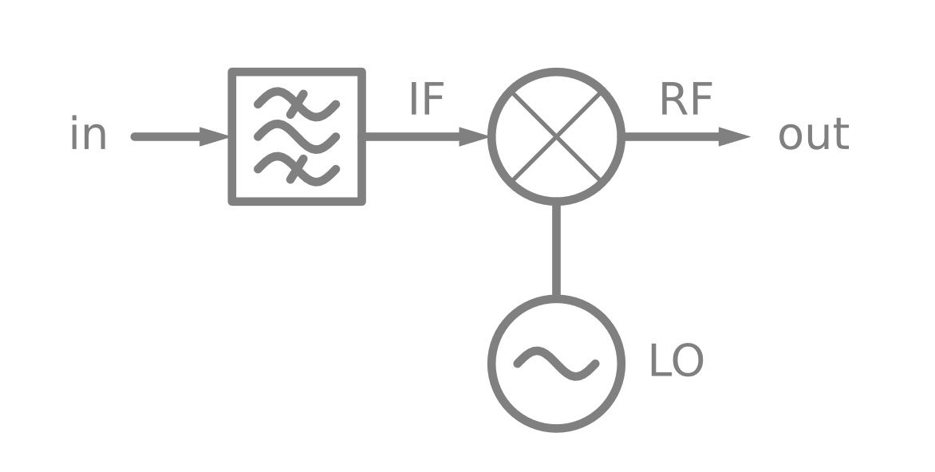 | 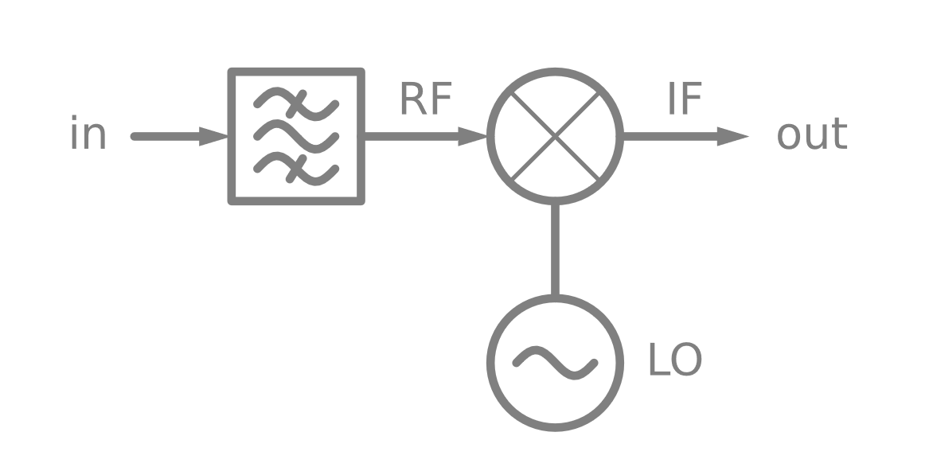
 | Receive | Upconverting Receiver with Fixed RF Output  $$n∙LO+m∙IF=RF$$ | Downconverting Receiver with Fixed IF Output  $$n∙LO+m∙RF=IF$$
 |  | 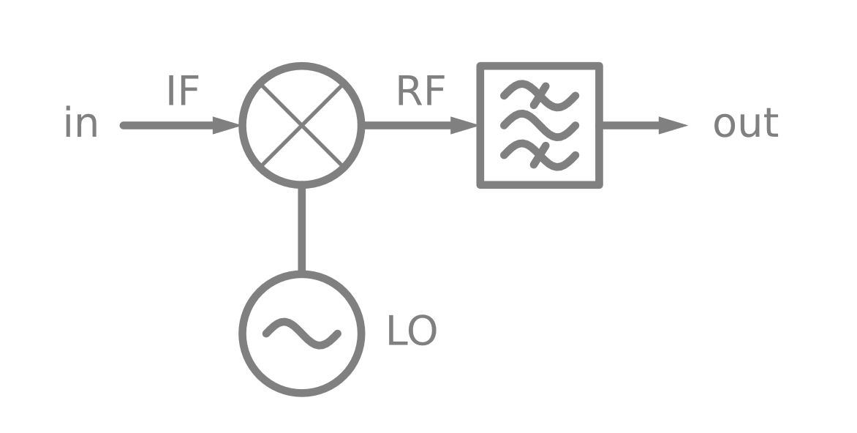 | 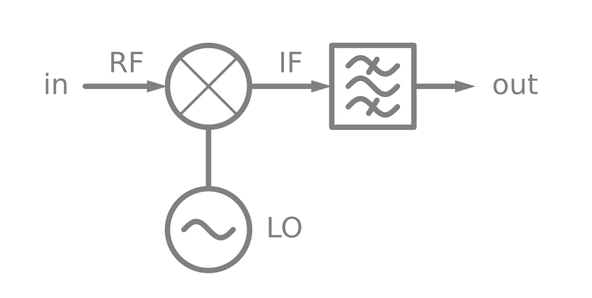

 |  | Mixer Orientation
 |  | IF In / RF Out | RF In / IF Out
Direction | Transmit | Upconverting Transmitter with Fixed IF Input | Downconverting Transmitter with Fixed RF Input
 |  |  | 
 | Receive | Upconverting Receiver with Fixed RF Output | Downconverting Receiver with Fixed IF Output
 |  |  | 

